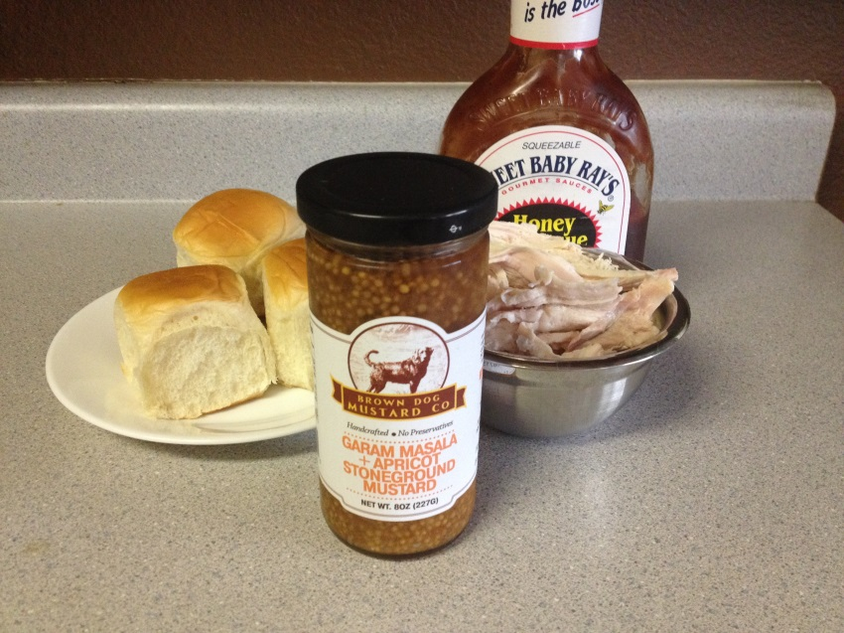
BBQ Chicken Sliders with Masala Apricot Mustard
1 rotisserie chicken
1 package Hawaiian Sweet Rolls
BBQ Sauce of Choice
Brown Dog Mustard Garam Masala & Apricot Mustard (Available for purchase in Mutt Lynch Gifts)

- Shred chicken off bones with hands and place in bowl
- Add BBQ sauce of choice
- Lay spoonfuls of the chicken on rolls
- Top with masala apricot mustard
- Enjoy!

